**UNGM vendor registration process (Practical information)**

Your company can create a profile in UNGM by accessing this link: <https://www.ungm.org/Account/Registration> and by simply following the simple on-screen instructions to register.

Key benefits of registering in UNGM are:

* Increased procurement opportunities for vendors by providing a platform where all UN Agencies tender opportunities are listed.
* UNGM provides one common UN global procurement portal where upon registration, a vendor is able to access UN Agencies procurement information including business seminars, knowledge centre on UN procurement, UN procurement statistics etc.

It is recommended that you register your company at **Basic Level** and at **Level 1** where the Certificate of your legal registration/incorporation is required to be attached.

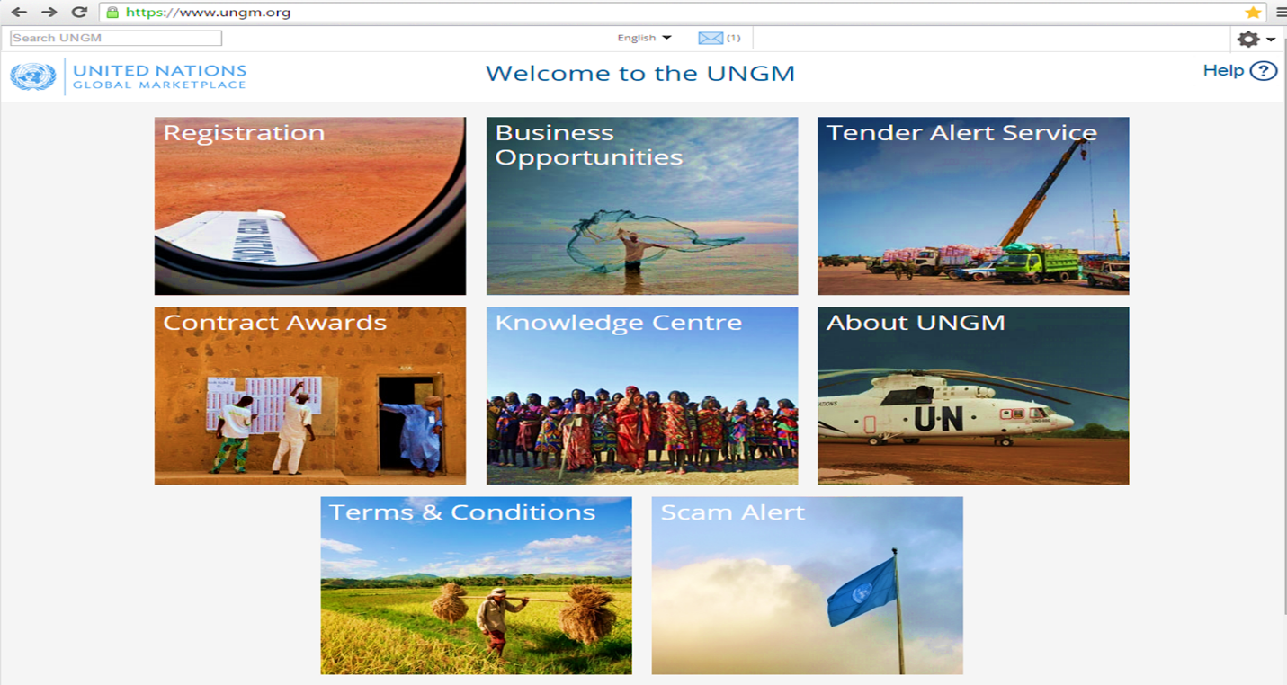

**In order to register as a potential vendor of UN organizations, please follow the instructions below:**

1. Go to <http://www.ungm.org>

2. Click on the **‘Login and New registration’ box** or on the **‘Register’ link** located at the top right corner of the page.

3. Click on the**‘New registration’ button**.

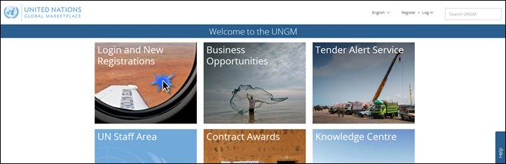

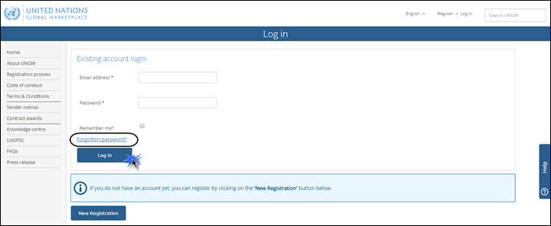

4. Please select the type of registration by clicking on the relevant box. Please click on the **‘Companies’ or ‘Individual Consultant’ as appropriate box.**

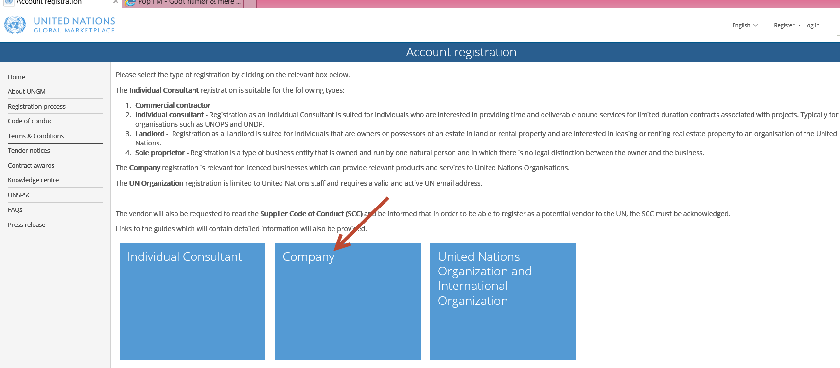

5. Introduce your company details and **accept the UN Supplier Code of Conduct**. Then, click on the **‘Register’ button**.

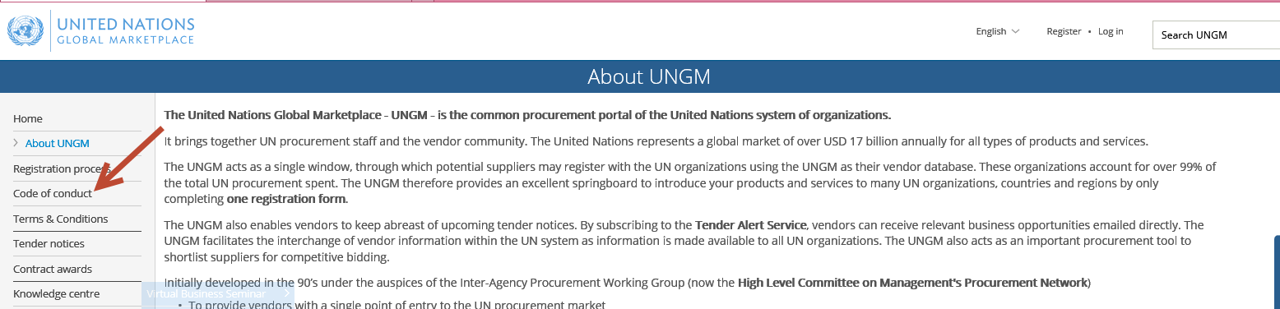

6. After registering, you will need to validate and activate the account. Go to your the **registered email inbox** corresponding to the email address provided when creating your account. You should have received an activation email. Please **click on the activation link** provided in this email.

(Example shown below)

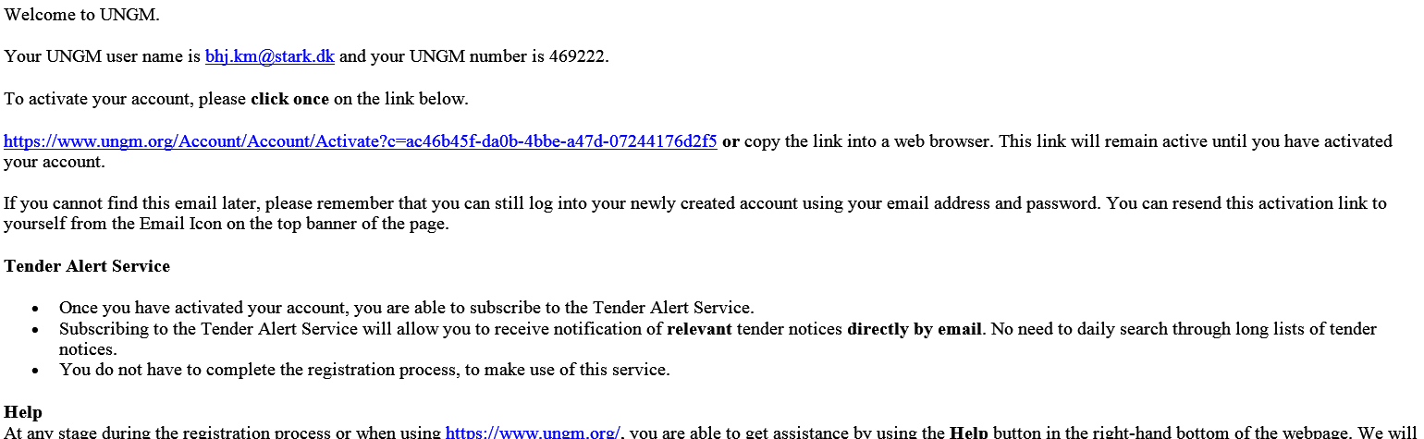

7. Once your account is activated, please click on the **'Registration' link** in the left-hand menu to access the registration form. Complete your vendor registration form in UNGM. When finished, please do not forget to click the **'Submit' button**.

Please complete the registration form and make sure all tabs are successfully filled.

Note: Tabs which appear in red have not been successfully completed.

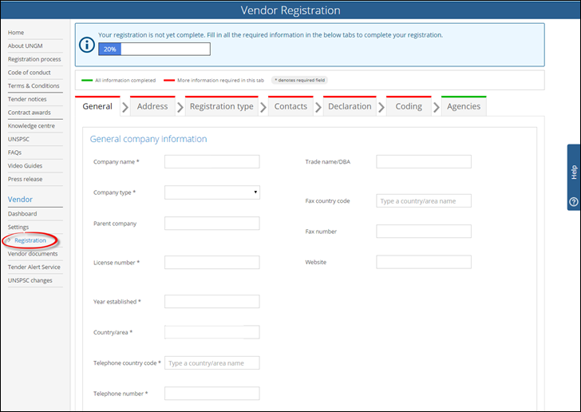

In the 'UN organizations' tab, please remember to review the list of UN organizations your company was matched with. Once you have considered which organizations you are interested in, please submit your registration form by clicking on the 'Submit my registration' button.

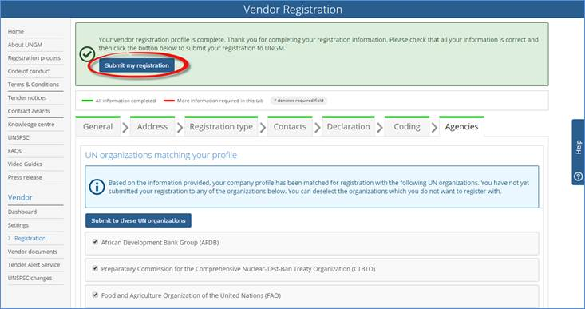

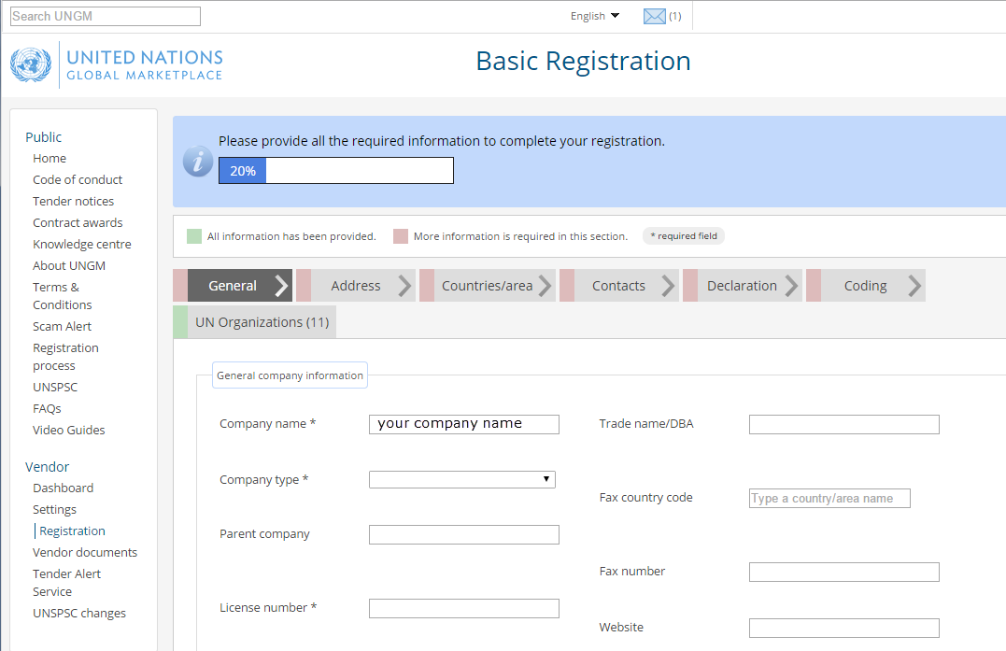

We also recommend you to review the **'Registration Process' link** in the left hand side menu for further information and detailed instructions on how to proceed in order to complete your UNGM Registration. <https://www.ungm.org/Public/Pages/RegistrationProcess>

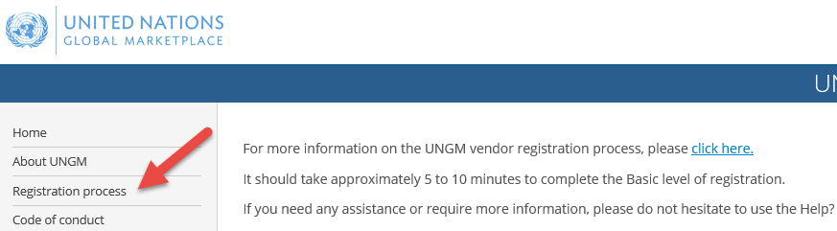

In addition, please find below the following video guideline on how to successfully register your company on UNGM: <https://www.ungm.org/Public/Video/View/3>

For further assistance, do not hesitate to contact your UNICEF contact or the UNGM administration office:

* + UNICEF contact: [**supplierapplication@unicef.org**](mailto:supplierapplication@unicef.org)
  + Via the **Help functionality** available on the site **www.ungm.org**
  + Via email at [**registry@ungm.org**](mailto:registry@ungm.org)

END